Note on different optimization methods, architectures and test metrics

Structured Pruning

a. Channel Pruning
Structured channel pruning experiments were performed on three convolutional neural network architectures:
- MobileNetV2
- VGG16
- ResNet50
For each architecture, channels were ranked using the L1-Norm filter importance criterion. Channels with the lowest importance scores were removed, and the corresponding network architecture was reconstructed by physically eliminating the selected channels. Weight transfer mechanisms were implemented to initialize the reduced models using the trained baseline weights, followed by fine-tuning to recover any loss in accuracy.
Calculate Scores: Compute the score s_{j} for every filter j in a given layer.
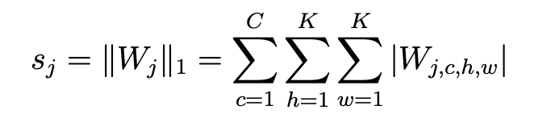
Sort: Rank the filters in ascending order based on their s_{j} scores.
Prune: Remove the top m filters with the smallest scores (the least "important" ones).
Remove Corresponding Channels: When you prune a filter in layer l, it no longer produces an output feature map. Therefore, you must also delete the corresponding input channels in the next layer (layer_{i+1}) to keep the matrix dimensions aligned.
b. Neuron Pruning
Fully connected layer pruning experiments were conducted on the VGG16 architecture. Later, this was performed in MobileNetV2 and ResNet50 as well, but since they had only 128 and 256 units in the Dense Layer, Neuron pruning had no notable impact in terms of reducing footprint size in the cases of these latter architectures.
Calculate Scores: Compute the importance score s_{j} for every neuron j in the fully connected layer by summing the absolute values of its incoming weights.
`
Sort: Rank the neurons in ascending order based on their s_{j} scores.
Prune: Remove the top m neurons with the smallest scores (the least "important" ones). This involves deleting the corresponding rows in the current layer's weight matrix W.
Remove Corresponding Weights: When you prune a neuron in a dense layer k, it no longer produces an output activation. Therefore, you must also delete the corresponding columns (incoming connections) in the weight matrix of the next dense layer (layer_{i+1}) to keep the matrix dimensions aligned for multiplication.
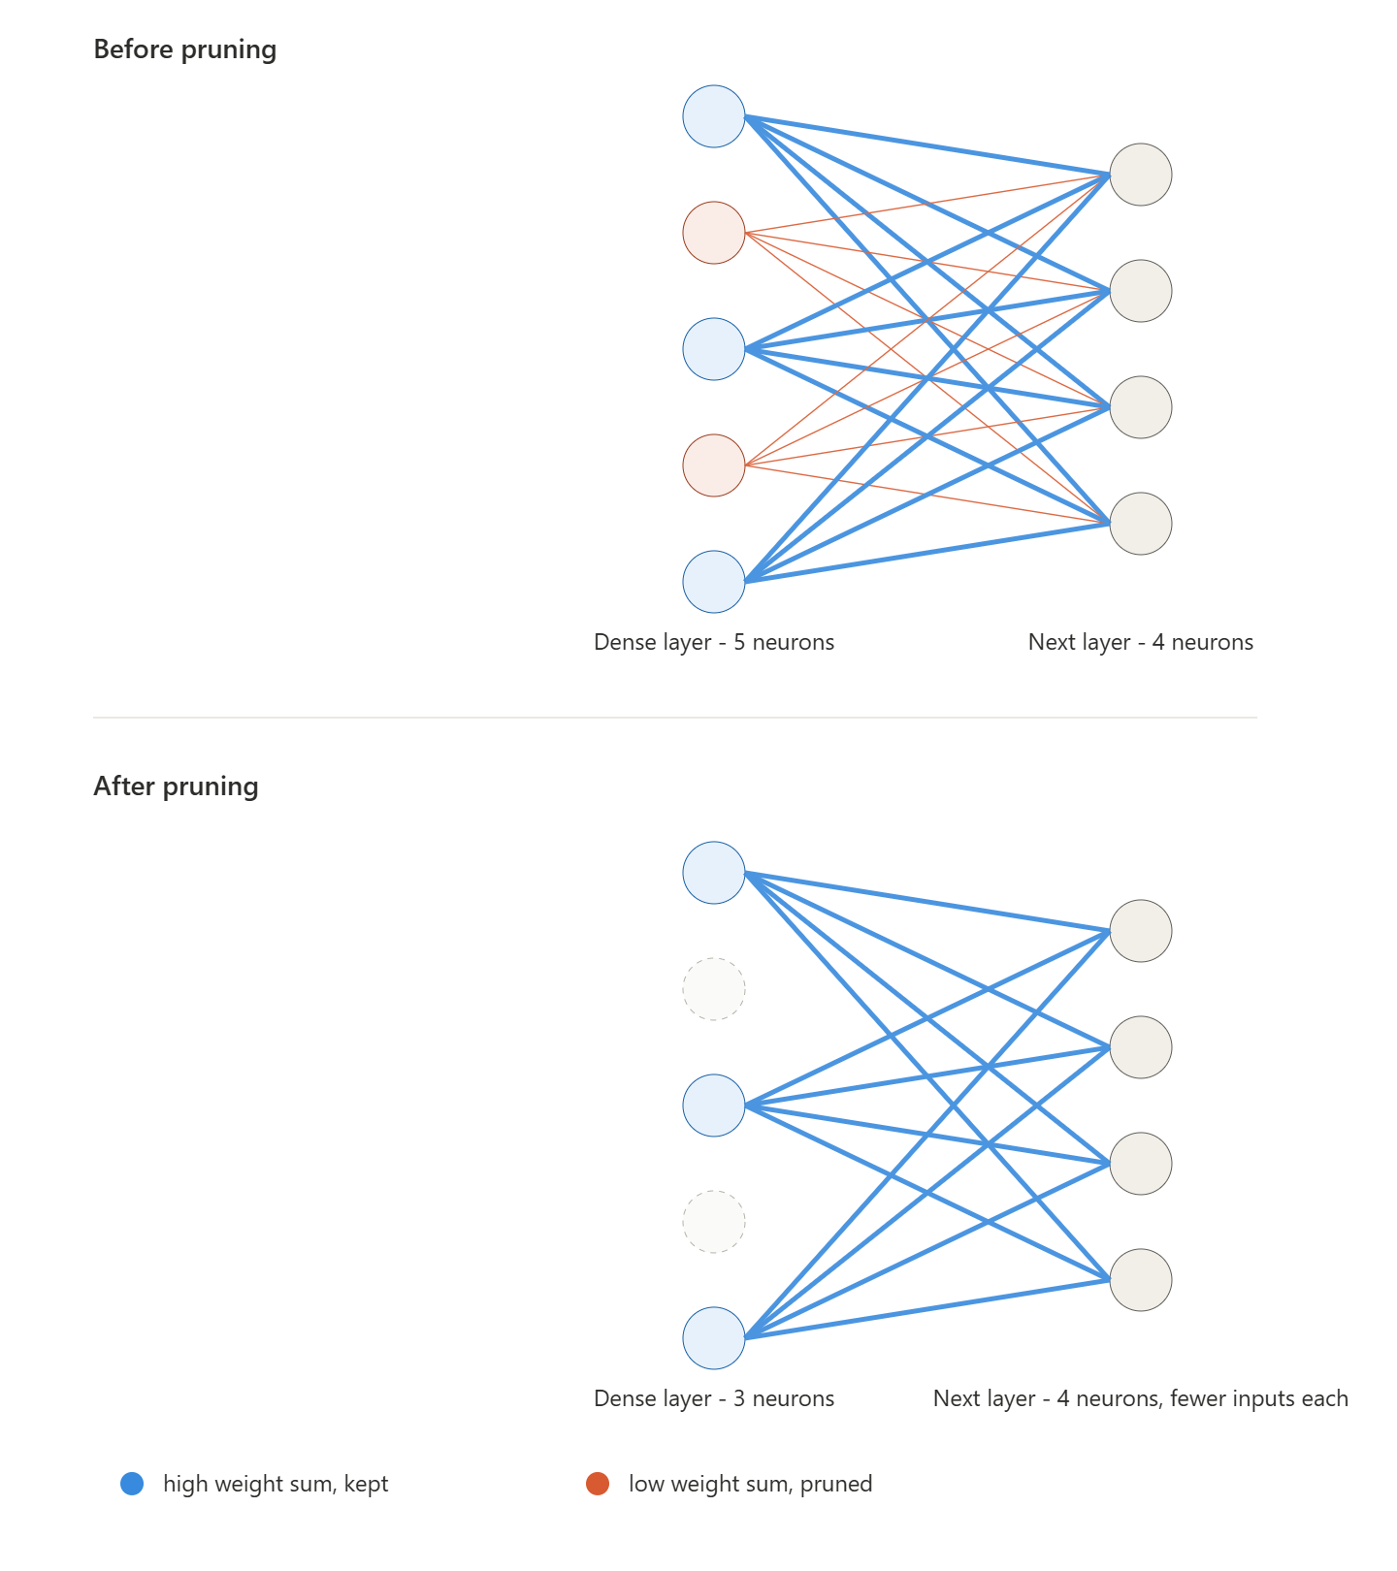
c. Layer Pruning
Layer pruning was performed by removing convolution layers (VGG16) or complete residual block (ResNet50) or inverted residual blocks (MobileNetV2) from the network architecture, thereby reducing its depth and computational complexity. The pruned models were reconstructed with the remaining layers, initialized using the retained weights from the baseline model, and fine-tuned to evaluate the impact of reduced network depth on classification accuracy and overall performance.
In MobileNetV2, a single block is made up of these layers, in order:
Expand layer -> Depthwise convolution -> Project layer -> Add layer (adds the block's input back to its output)
In ResNet50, a single block is made up of these layers, in order:
1x1 convolution -> 3x3 convolution -> 1x1 convolution -> Add layer (adds the block's input back to its output)

The blocks are removed based on the impact of the layer on the output;
VGG16 - using the magnitude of the weights of the layer
ResNet50, MobileNetV2 - how much the tensor is changes when it passes the block [( output tensor - input tensor)/ input tensor]
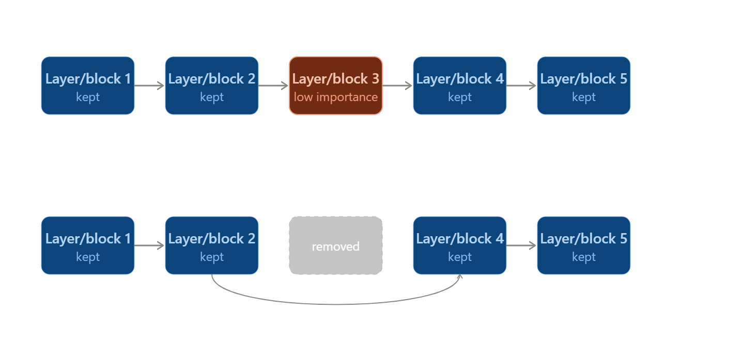

Dropout

Dropout regularization was implemented by randomly deactivating a specified fraction of neurons during each training iteration, to prevent co-adaptation among features and reduce overfitting.
Multiple dropout ratios were evaluated to study their effect on model generalization, training stability, and classification performance.
Let a^{[l]} represent the activation vector of a given layer l prior to regularization. We generate a binary mask vector d^{[l]} (vector with entries 0 or 1, with the purpose of masking) of the identical shape, where each element is independently drawn from a Bernoulli distribution with a retention probability p = keep_prob, where the dropout ratio is defined as 1−p - this is given in a parameter as an input.
Mathematically,
d^{[l]}∼Bernoulli(p)
a^{[l]} = a^{[l]}⊙d^{[l]}
Where ⊙ denotes the element-wise product of two matrices.
So how this works is that there’s 1-keep_prob chance of d^{[l]} being 0. Hence 100*(1-keep_prob)% of entries are zeroed out in the product step a^{[l]} = a^{[l]}⊙d^{[l]}

The Scaling Problem and Inverted Dropout
Because a fraction of the neurons are shut down during training, the expected value of the total activation sum flowing into the subsequent layer is scaled down by a factor of p. If left unadjusted, the network would output disproportionately large activations during inference (testing), where all neurons are active (p=1).
To resolve this without altering the test-time architecture, Inverted Dropout is implemented. We scale the activations during the training phase by dividing the masked activations by the retention probability p. This ensures that the expected value of the activations remains identical between training and testing.
The complete forward pass formulation under Inverted Dropout becomes:

a^{[l]} = (a^{[l]}⊙d^{[l]})/p.

We do not use dropouts at test time. Dropouts are exclusively applied during training to prevent overfitting. During the test (or evaluation) phase, we turn off dropouts so the model uses all of its neurons to make deterministic predictions.

Additionally, it is important to note that dropout doesn’t decrease the number of parameters of the model. Hence, the footprint size remains untouched.
PS: We directly use the model’s inbuilt implementations of dropouts, but the explanation and working methodology is as given above.

Quantization
Quantization reduces a network's memory footprint and compute cost by lowering the numerical precision of its weights and activations. This is done by mapping continuous FP32 values to a discrete lower-bit integer format (INT16, INT8, or an INT4-equivalent), shrinking storage size accordingly.
We applied three quantization schemes — full INT8, INT16-activation/INT8-weight, and INT4-equivalent via weight clustering (might be removed) — across all three architectures (VGG16, MobileNetV2, ResNet50).
1. Full INT8 Post-Training Quantization (PTQ)
- Both weights and activations are quantized to 8-bit integers using calibration statistics gathered from a representative subset of the training data.
- Load the trained FP32 Keras model.
- Build a representative dataset generator: ~100–200 images drawn from the train split (never test, to avoid leaking test statistics into calibration ranges), preprocessed identically to training.
- Run TFLiteConverter with Optimize.DEFAULT, target_spec.supported_ops = [TFLITE_BUILTINS_INT8], and inference_input_type = inference_output_type = tf.int8, so every operation, including the model's input/output tensors is quantized, with no float fallback.
- The converter uses the representative dataset to observe per-tensor activation ranges and derives a (scale, zero_point)pair for each tensor.
- At inference, inputs are quantized (q = round(x/scale) + zero_point, clipped to [-128, 127]) and outputs are dequantized (x = (q - zero_point) * scale) using those same values.
2. INT16-Activation / INT8-Weight Post-Training Quantization ("16x8")
TFLite has no native full-INT16 scheme, so we used the experimental 16x8 mode: activations at INT16 (wider dynamic range, less error-prone), weights kept at INT8 (size stays close to the INT8 model).
Same calibration setup as full INT8 (representative dataset from train split).
Convert with target_spec.supported_ops = [EXPERIMENTAL_TFLITE_BUILTINS_ACTIVATIONS_INT16_WEIGHTS_INT8].
inference_input_type/output_type are not forced — this operation set doesn't reliably support setting them, so the converter may leave float32 boundary tensors (16x8 only internally) or expose int16 I/O directly, depending on TF version.
Evaluation therefore reads the interpreter's actual input/output type at runtime rather than assuming either case, and quantizes/dequantizes only if the boundary tensors turn out to be integers.

Architectures

- VGG16:
Overview: VGG16 is a fundamental Convolution Neural Network(CNN), it consists of 16 total layers - 13 convolution layers and 3 fully connected layers.
Network Structure:
Input layer: It takes 224x244 RGB images as input.
Convolution layers: It consists of 5 blocks, each with 2 or 3 convolution layers (3x3 convolution filter, stride 1, same padding) followed by a 2x2 max-pooling layer (stride 2).
Classification Head: The model ends with 2 fully connected (Dense) layers, each with 4096 neurons and is followed by the final output fully connected layer.

- ResNet50:
Overview: ResNet50 is a 50 layer Convolutional Neural Network(CNN) that uses residual skip connections.
Network Structure:
Input layer: it takes 224x224 RGB images as input
Initial Convolution layer: contains a 7x7 convolution layer, followed by 16 Residual blocks.
Residual Block: consists of a
1x1 convolution layer that reduces the no of channels then a
3x3 convolution layer for feature extraction then a
1x1 convolution layer that expands the channels.
Convolution layers: following the 7x7 convolution layer the architecture consists of 4 stages, first stage has 3 Residual blocks with 256 output channels, followed by stage 2 with 4 Residual blocks with increased 512 output channels, followed by stage 3 with 6 residual blocks with 1024 output channel and then stage 4 with 3 residual blocks with 2048 output channels
Classification Head: contains a Global Average pooling followed by a dense layer.

- MobileNetV2:
Overview: MobilleNetV2 is a light weight Convolutional Neural Network that was designed for resource constrained devices.
Network Structure:
Input layer: It takes 224x224 RGB images as input.
Initial Convolution layer: it begins with a 3x3 convolution, followed by 17 Inverted Residual Blocks.
Inverted Residual Layer: Each Block consists of a
1x1 expansion layer that expands the no of channels, followed by a
filtering layer with a 3x3 depthwise convolution layer and then a
1x1 projection layer that shrinks the tensor. It also contains a skip connection between the input and the out of the Inverted Residual Block.
Classification Head: it contains a 1x1 convolution layer followed by a Global Average Pooling then a final dense layer.

System Configuration

- System:
  - Configuration
- All model training and evaluation experiments were carried out on a workstation (DESKTOP-O6BRAQR) equipped with an Intel Xeon W-2125 CPU running at 4.00 GHz, paired with 64.0 GB of installed RAM (63.7 GB usable) to comfortably handle large in-memory datasets and batch operations.
- Graphics acceleration was provided by an NVIDIA Quadro P5000 with 16 GB of VRAM, which enabled efficient GPU-based training and inference for the deep learning models used in this study.
- Storage was handled by a 932 GB Toshiba MG03ACA100 HDD, and the system ran a 64-bit operating system on an x64-based processor architecture.
- The tensorflow version in the system was 2.9.0
- This hardware configuration provided sufficient compute and memory headroom to train and evaluate multiple CNN architectures (VGG16, MobileNetV2, and ResNet50) across their various pruned and regularized variants without resource bottlenecks.

  - Evaluation method
- To ensure a fair and consistent comparison across all model variants, a single held-out test split was created from the CSIR leather defect dataset and reused across every architecture, rather than generating a new split per model.
- The dataset was balanced by sampling 3,992 defect-free and 3,992 defective images, shuffled with a fixed random seed for reproducibility, and divided into training (65%), validation (15%), and test (remaining ~20%) sets.
- Since VGG16, MobileNetV2, and ResNet50 each expect differently preprocessed inputs, the raw, unprocessed test images were loaded once and then passed through architecture-specific preprocessing functions at evaluation time.
- This guaranteed that every model was tested on the exact same underlying images while still receiving properly normalized inputs.
- Jetson TX2:
- Configuration:
  - Jetson TX2 is a high performance AI computing device, it contains a 256-core NVIDIA Pascal architecture GPU with a max frequency of 1.3GHz capable of 1.33 TFLOPS of performance, along with a Dual-core NVIDIA Denver 2 64-bit CPU and quad-core Arm Cortex-A57 MPCore processor, with max frequency of 2GHz for both of them.
  - The system contains 8GB 128-bit LPDDR4 memory with bandwidth of 59.7GB/s and a 32GB eMMC 5.1 for storage.
  - Jetpack 4.6.6 was installed on the board and tensorflow 2.6.2.

- Evaluation method:
- The whole dataset was loaded on the board and only the test dataset was prepared with it taking 20% of the original dataset.
- The saved models are loaded from the .keras files and preprocessing is done on the dataset based on the architecture from the applications module.
- The model is evaluated 7 times and the time of evaluation is summed and divided by no of images in the dataset and by 7 to get the inference time.
3. Jetson Orin Nano:
- Configuration:
- Jetson Orin Nano is a high performance AI computing device, it contains a NVIDIA Ampere architecture with 1024 CUDA cores and 32 tensor cores GPU capable of 1.33 TFLOPS of performance, along with a 6-core Arm Cortex-A78AE v8.2 64-bit CPU 1.5MB L2 + 4MB L3 CPU and quad-core Arm Cortex-A57 MPCore processor, with max frequency of 2GHz for both of them.
- The system contains 8GB 128-bit LPDDR5 memory with bandwidth of 102GB/s and supports SD card and externalNVMe.
- The tensorflow version was 2.6.2.
- Evaluation method:
- The whole dataset was loaded on the board and only the test dataset was prepared with it taking 20% of the original dataset.
- The saved models are loaded from the .keras files and preprocessing is done on the dataset based on the architecture from the applications module.
- The model is evaluated 7 times and the time of evaluation is summed and divided by no of images in the dataset and by 7 to get the inference time.

Performance Metrics

- Accuracy:
Accuracy is the number of times the model has made correct predictions compared to the total number of predictions.
$Accuracy =\frac{Number of correct predictions}{Total number of predictions}$

- Loss:
Loss is a numerical value that says how far the predicted labels of a model are from the actual labels of the data.
Test Loss = -(1/N) ·$\sum_{i=1}^{N}{}$[ yᵢ·log(ŷᵢ) + (1-yᵢ)·log(1-ŷᵢ) ]
Where,
N is the total number of test samples (test_size)
$y_{i}$ is the true label
$\hat{y_{i}}$is the predicted label of the model.

- Footprint Size:
Footprint Size is the total amount of physical memory the saved model occupies.
- Inference Time: Inference Time is the amount of time a trained model requires to take a singular input and provide its output.

